Overview
This particular safari starts ands in Entebbe. It takes you to the most-visited safari parks which offer excellent wildlife viewing and photographic opportunities. Abundant wildlife guaranteed. Highlight; Shoebill boat safari, Gorilla trekking at Bwindi, Chimpanzee trekking at Kibale, Classic boat cruise along kazinga channel to mweya peninsular, Endangered golden monkey at Mgahinga gorilla national park, Rhino trekking at Ziwa sanctuary, Viewing falls at Murchison falls park and many others.

Route

Uganda
Start | Entebbe (Day 1)
Day 1 | Entebbe Airport (Entebbe)
Day 2 | Mabamba Swamp
Day 3-4 | Murchison Falls NP
Day 5 | Kibale NP (Chimps)
Day 6 | Queen Elizabeth NP
Day 7-9 | Bwindi Impenetrable NP (Gorillas)
Day 10 | Lake Mburo NP
End | Entebbe (Entebbe) (Day 11)

Tour Features

Mid-range tour
This mid-range tour uses lodges and guest houses.

Shared tour
On this shared tour, you will join a group of other travelers. Max 3 people per vehicle.

Can start any day
If availability permits, this tour can start on any day.

Cannot be customized
The accommodations and destinations of this tour cannot be changed.

Suitable for single travelers
Single travelers can join this group tour, but it requires a minimum of 2 people to run.

Minimum age of 18 years
The minimum age for this tour is 18 years.

Activities & Transportation
- Activities: game drives, gorilla trekking, chimpanzee trekking, walking safaris (with an armed guide), specialized birding (with a professional birding guide) & boat trip
- Game drives: pop-up roof 4x4 vehicle
- Getting around: pop-up roof 4x4 vehicle & boat
- A transfer from and back to the airport is included

Accommodation & Meals
- Additional accommodation before and at the end of the tour can be arranged for an extra cost
- Day
Accommodation
Meals
- 1
Airport Guesthouse EntebbeMid-range guest house in Entebbe (City)

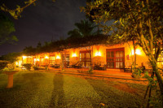

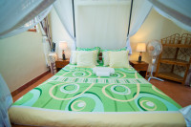

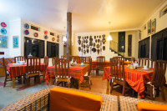

All Meals Included
- 2
Ziwa Rhino and Wildlife Ranch - Guest HouseBudget guest house in Ziwa Rhino Ranch

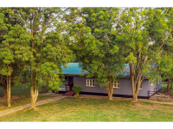

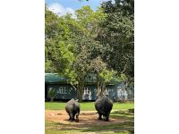

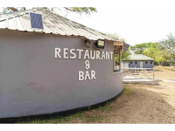

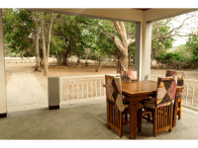+6Photos

All Meals Included
- 3-4
Pakuba Safari LodgeMid-range lodge inside Murchison Falls NP

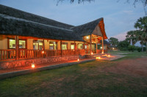

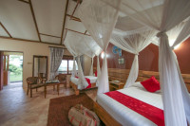

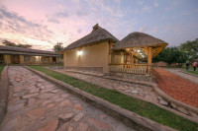

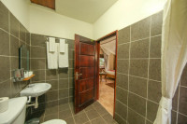+4Photos

All Meals Included
- 5
Chimpanzee Forest LodgeMid-range guest house just outside Kibale NP (Chimps)

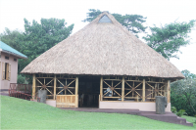

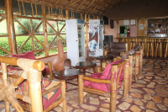

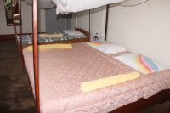

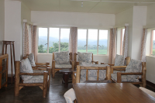

All Meals Included
- 6-7
Enshama Game LodgeMid-range lodge just outside Queen Elizabeth NP

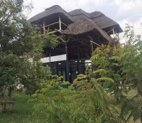

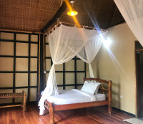

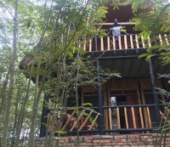

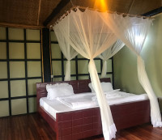

All Meals Included
- 8-9
Bweza Gorilla LodgeMid-range lodge just outside Bwindi Impenetrable NP (Gorillas)

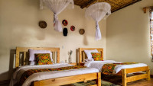

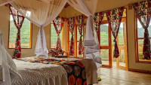

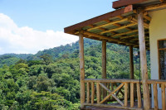

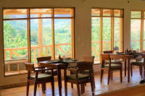

All Meals Included
- 10
Rwakobo Rock LodgeMid-range lodge just outside Lake Mburo NP

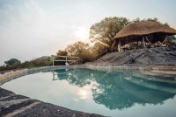

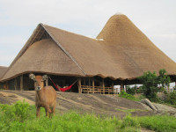

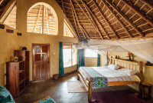

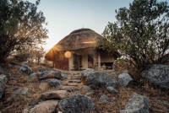+6Photos

All Meals Included
- 11
End of tour
(No accommodation)
Breakfast & Lunch Included

Interested in This Tour?

